Southern Tier Chapter of
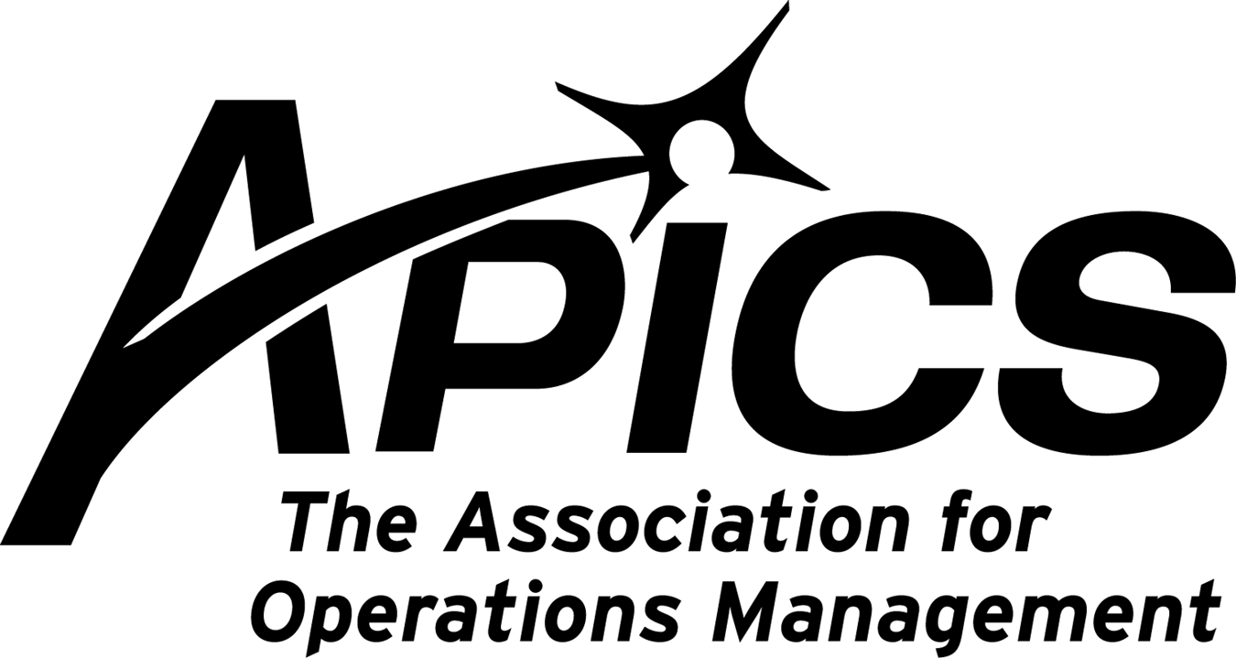
www.stapics.org

“Advancing productivity and innovation and competitive success.”

NO SEPTEMBER DINNER MEETING

APICS NE DISTRICT LEADERS

The results of the election of our district leaders for the two year term beginning January 2011 are:

David Rivers will be our new District Director
Jennifer Kevlin will be our new District Manager

Please join us in congratulating and wishing the best of luck and all our support to them as they begin their next role in APICS.

Be sure you receive emails from APICS. Add mktadmin@apics.org to your address book.

Registering for APICS 2010 is easy. CLICK or call (800) 444-2742 or (773) 867-1777 today.

Real-World Techniques and Best Practices to Help You and Your Organization Be Lean

2010 APICS International Conference & Expo
October 18–20, 2010
Wynn Las Vegas | Las Vegas, Nevada, USA

Attend sessions from one of seven relevant Learning Paths designed to expand your understanding of a variety of best practices and techniques critical to success in today's global economy at APICS 2010.

Featured Learning Path | Lean
Deepen your understanding and learn practical applications for methods and mind-set to build a solid lean operating environment. Educational sessions will help you apply lean operations best practices in your organization, no matter the
size and industry; enhance and prioritize continuous improvement; and more.

The Lean Learning Path is sponsored by IBM.

A Journey to Sustainable Continuous Improvement
Soli Engineer, CPIM
President, SJE Consultants & Associates
Michael Bowman
President, Hunt & Hunt Ltd.

Hunt & Hunt Manufacturing is a machine shop specializing in multi-axis machining, laser cutting, and high-volume production of perforating guns for the oil industry. In 2007, the company president began a journey to continuous improvement. This presentation will reveal the results of his plan and explore the most significant areas addressed along the way—including adjusting employee mindsets, setup reduction, eliminating paper on the shop floor, reduced work-in-process inventory, and much more.

Monday, October 18
8:00 a.m.-9:15 a.m.
Lean On Your Information Technology Capabilities

1:00 p.m.-2:15 p.m.
Lean Execution Lessons Learned

2:30 p.m.-3:45 p.m.
A Journey to Sustainable Continuous Improvement

4:00 p.m.-5:15 p.m.
Lean Six Sigma in the Service Sector

Tuesday, October 19
8:00 a.m.-9:15 a.m.
Motivating Your People for the Long Journey to Lean

1:00 p.m.-3:30 p.m.
Reaping Lean Rewards

3:45 p.m.-5:00 p.m.
Building Up Lean in Construction

Wednesday, October 20
10:30 a.m.-11:45 a.m.
Lean in Health Care Through A3 Problem Solving

1:30 p.m.-2:45 p.m.
Changing People, Processes, and Paradigms

3:00 p.m.–4:15 p.m.
Lean Is Green

Click to view the educational program
Earn up to 24 professional development points toward your APICS certification maintenance.

2010 World Café
Join us Wednesday, October 20 for the third-annual APICS World Café. Participate in this popular discussion to deepen your understanding of the future of your profession and have your opinion heard through the engaging World Café
format.

Announcing the 2010 APICS Career Fair: Online and On-site at APICS 2010
Job seekers in operations and supply chain management: Get ready to be noticed! Make sure your résumé is up to date and posted online at the APICS Career Center.

Stop by the Career Connections booth at the APICS International Conference & Expo October 18–20 to take advantage of career development presentations and information on how you can leverage your APICS membership and certification in your career.

Employers: Stay tuned for information on how you can turn a job listing in the 2010 APICS Career Fair into more than $5,000 in exposure for your organization.

© 2010 APICS The Association for Operations Management.
APICS • 8430 West Bryn Mawr Avenue, Suite 1000, Chicago, IL 60631 • 773.867.1777 or 800.444.2742 • www.apics.org



Your 2010-2011 Board of Directors

President / VP Education Dave Gardner dgardner@akraturn.com
VP Membership / Website Lee Schechter lschechter@stny.rr.com
Executive VP / Director of Finance Steve Whited steve.whited@mwv.com
Director of Education Don Sheldon dsheldon@stny.rr.com
Publicity / Marketing / Programming Michael LoSapio Michael.losapio@synergyresources.net
Marketing Director Kelly Norieka Kelly.norieka@lmco.com
Secretary Deb Unkel deb.unkel@raymondcorp.com

Southern Tier APICS
PO Box 1107
Binghamton NY 13902-1107

