Southern Tier Chapter of
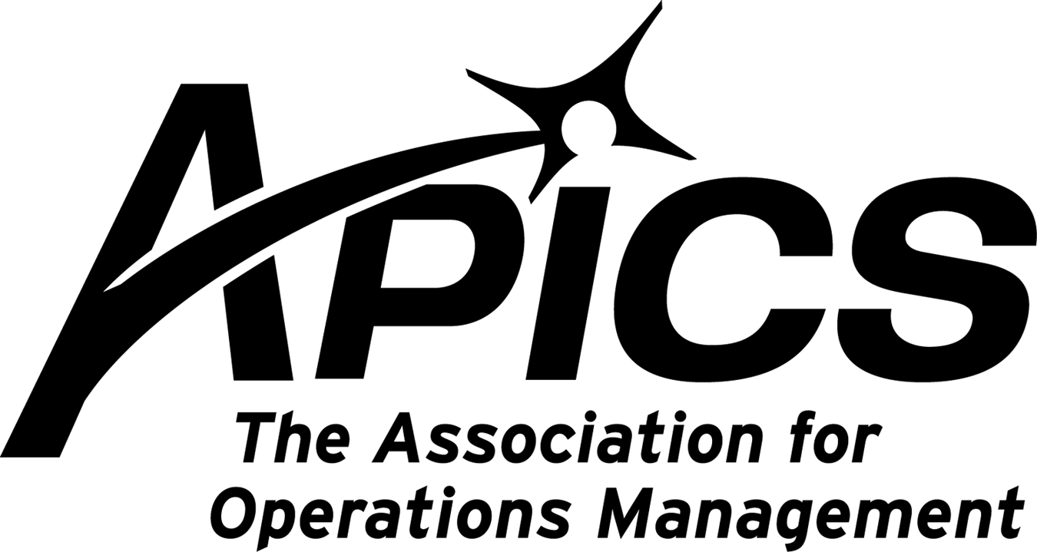
www.stapics.org

“Advancing productivity and innovation and competitive success.”

OCTOBER DINNER MEETING

Joint Meeting with NAPM

Thursday, October 21, 2010

Location: Grande Restaurant on Upper Front Street
(Northgate Plaza)

5:30PM Sign-in and Networking
6:00PM Dinner
7:00PM Vikki Collazo on ‘Broome County – State of Affairs’

Cost: $15.00 (members) $20.00 (non-members)

RSVP by October 19th to Keith_Jamba@uhs.org or by calling 763-5138

Our speaker, Vikki Collazo, is Manager of Membership & Marketing for Greater Binghamton Chamber of Commerce. Vikki was born and raised in Binghamton and decided to seek the excitement of New York City for 15 years, only to return to her native roots to raise her son. She has been back in the area now for 13 years and agrees that "it was the best decision she ever made", returning to her home town. Her hospitality sales and tourism background is a great asset for the Chamber. Her position includes coordinating all Chamber events, communications and connecting members within the Chamber membership.

APICS NE DISTRICT LEADERS

The results of the election of our district leaders for the two year term beginning January 2011 are:

David Rivers will be our new District Director
Jennifer Kevlin will be our new District Manager

Please join us in congratulating and wishing the best of luck and all our support to them as they begin their next role in APICS.

Be sure you receive emails from APICS. Add mktadmin@apics.org to your address book.

Registering for APICS 2010 is easy. CLICK or call (800) 444-2742 or (773) 867-1777 today.

Real-World Techniques and Best Practices to Help You and Your Organization Be Lean

2010 APICS International Conference & Expo
October 18–20, 2010
Wynn Las Vegas | Las Vegas, Nevada, USA

Attend sessions from one of seven relevant Learning Paths designed to expand your understanding of a variety of best practices and techniques critical to success in today's global economy at APICS 2010.

Featured Learning Path | Lean
Deepen your understanding and learn practical applications for methods and mind-set to build a solid lean operating environment. Educational sessions will help you apply lean operations best practices in your organization, no matter the size and industry; enhance and prioritize continuous improvement; and more.

The Lean Learning Path is sponsored by IBM.

A Journey to Sustainable Continuous Improvement
Soli Engineer, CPIM
President, SJE Consultants & Associates
Michael Bowman
President, Hunt & Hunt Ltd.

Hunt & Hunt Manufacturing is a machine shop specializing in multi-axis machining, laser cutting, and high-volume production of perforating guns for the oil industry. In 2007, the company president began a journey to continuous improvement. This presentation will reveal the results of his plan and explore the most significant areas addressed along the way—including adjusting employee mindsets, setup reduction, eliminating paper on the shop floor, reduced work-in-process inventory, and much more.

Monday, October 18
8:00 a.m.-9:15 a.m.
Lean On Your Information Technology Capabilities

1:00 p.m.-2:15 p.m.
Lean Execution Lessons Learned

2:30 p.m.-3:45 p.m.
A Journey to Sustainable Continuous Improvement

4:00 p.m.-5:15 p.m.
Lean Six Sigma in the Service Sector

Tuesday, October 19
8:00 a.m.-9:15 a.m.
Motivating Your People for the Long Journey to Lean

1:00 p.m.-3:30 p.m.
Reaping Lean Rewards

3:45 p.m.-5:00 p.m.
Building Up Lean in Construction

Wednesday, October 20
10:30 a.m.-11:45 a.m.
Lean in Health Care Through A3 Problem Solving

1:30 p.m.-2:45 p.m.
Changing People, Processes, and Paradigms

3:00 p.m.–4:15 p.m.
Lean Is Green

Click to view the educational program
Earn up to 24 professional development points toward your APICS certification maintenance.

2010 World Café
Join us Wednesday, October 20 for the third-annual APICS World Café. Participate in this popular discussion to deepen your understanding of the future of your profession and have your opinion heard through the engaging World Café format.

Announcing the 2010 APICS Career Fair: Online and On-site at APICS 2010
Job seekers in operations and supply chain management: Get ready to be noticed! Make sure your résumé is up to date and posted online at the APICS Career Center.

Stop by the Career Connections booth at the APICS International Conference & Expo October 18–20 to take advantage of career development presentations and information on how you can leverage your APICS membership and certification in your career.

Employers: Stay tuned for information on how you can turn a job listing in the 2010 APICS Career Fair into more than $5,000 in exposure for your organization.

© 2010 APICS The Association for Operations Management.
APICS • 8430 West Bryn Mawr Avenue, Suite 1000, Chicago, IL 60631 • 773.867.1777 or 800.444.2742 • www.apics.org

APICS Announces New e-Memberships

APICS is making it easier for operations and supply chain professionals to become part of the APICS community with the introduction of three new electronic membership categories. APICS now offers electronic membership options to enterprises, international members, and young professionals. Please encourage eligible members and organizations to participate.
Enterprise Professional e-Membership
Available to organizations with 25 or more enterprise members, this new membership type enables companies to provide more employees with access to valuable APICS content, products, and services.
Whether an organization is in the process of converting former corporate associates to the new membership structure or is a new APICS Enterprise Member, it will benefit from this affordable membership option. This membership may be transferred to other employees in the organization, giving companies the flexibility to maximize their budgets.
Enterprise Professional e-Members receive member benefit materials electronically, local chapter membership, training and certification exam registration at discounted rates, voting privileges with the ability to hold elected office and serve on committees, and eligibility for certification maintenance points. The e-membership dues amount for companies with 25 or more enterprise members is $125 per member.
Partners working with eligible organizations who would like to participate should contact APICS Customer Support at (800) 444-2742 or (773)-867-1777.
International Professional e-Membership
The new International Professional e-Membership was created to support the rapidly expanding global operations and supply chain management community. This membership type offers electronic access member benefits. Members worldwide can now receive APICS content and relevant industry information quickly and efficiently. In addition to savings on the regular membership rate, International e-Members are eligible for certification maintenance points and to receive training and certification exams at a special rate from participating representatives. Program participants who have International Associates in their countries will also benefit from joint membership with the local organization.
The dues amount for the International Professional e-member type is $125 per member.
The International Professional e-Membership application may be accessed here: https://www.apics.org/sitefiles/forms/international.html
Young Professional e-Membership
Specifically for recent graduates, the Young Professional e-Membership offers the opportunity to build a professional network and expand operations and supply chain management knowledge—at a price that’s a perfect fit for a young professional’s budget. Young Professional e-Members receive earth-friendly electronic versions of all member benefit materials, including the online edition of APICS magazine, training and certification exam registration at discounted rates, local chapter membership, and are eligible for certification maintenance points.
Young Professional e-Membership annual dues are $100. This membership option is available only to individuals who have at least one full year of previous APICS student membership and is limited to a two-year period.
The Young Professional e-Membership application may be accessed here: https://www.apics.org/sitefiles/forms/young_professional.html
These forms are also available for download and can be found on C-BOX. The e-membership forms will also be available for order from the APICS Bookstore soon. More details will be provided later.
Now Available! APICS Academic Professional Membership Online Application
Due to popular demand, the APICS Academic Professional Membership application is now available online.
The APICS Academic Professional Membership application may be accessed here:
https://www.apics.org/sitefiles/forms/academic.html
Academic Professional members contribute to the expansion of the APICS body of knowledge; strengthen education, training, and resources in operations management; and provide guidance to students entering the workforce.
To sign up or receive more information about these membership options, call APICS Customer Support at (800) 444-2742 or (773) 867-1777.

APICS News from Don Sheldon, Vice President of Education

Re-Certification – An outstanding offer is currently being made from APICS for people whose certification has lapsed. The opportunity is limited so you must react soon.

The Southern Tier APICS Chapter is proposing a study group led by a Master Trainer (Either Dave Gardner or me) to do readiness training for the recertification exam. It will be scheduled once we have a roster of interested students. We are entertaining 4 afternoons (16 hours total-probably 2-6pm each session) to review materials from study notes. We will also do practice questions similar to what might be on the exam.

The Cost will be $250 plus the book cost. We will use the 2010 APICS CPIM Exam Content Manual which can be downloaded with qualification approval by APICS for free (see http://www.apics.org/Certification/RecertificationExam.htm) and Brian Willcox Study Notes series also from APICS ($147).

If you are interested in this study class, please contact me at dsheldon@sheldoninc.com. If we get enough to sign up, we will run it. Thanks!
Don

CONGRATULATIONS DAVE GARDNER!!!
Attained CPIM Certification Extension through the APICS maintenance program

Dear Chapter Leaders,

Providing APICS certification candidates with the most flexible options for exam testing is critical to the success of our certification programs and a key element of the APICS strategic priorities. Recent updates to APICS certification exam delivery have been well received and are being used increasingly by certification candidates. Following is an update on the APICS paper-and-pencil exam testing and chapter group testing price.

APICS CSCP Paper-and-Pencil Exam Testing
APICS has received an overwhelming interest in the APICS Certified Supply Chain Professional (CSCP) computer-based testing (CBT) exam since its rollout in 2009. Candidates prefer the CBT format thanks to faster access to results, flexibility in deciding when and where to take the exam, and more convenient exam locations. Taking these factors into consideration, effective January 1, 2011, APICS will no longer offer public APICS CSCP paper-and-pencil sites through ACT in North America. The APICS CSCP exam will be offered in Pearson VUE CBT window format only.

Please inform your chapter members about the APICS CSCP certification update and encourage them to register for the December 4, 2010-January 15, 2011, exam window. Reservations for the December–January window open October 6, 2010.

Chapter Group Testing Update
On Monday, July 26, APICS announced product pricing updates effective January 1, 2011. Effective January 1, 2011, the chapter group testing price will change from $135 to $145, consistent with the advertised member rate for the exam.

If you have questions, please contact APICS at certification@apics.org.

Sincerely,
Lisa Sallstrom
Director, Certification

APICS
DETAILED SCHEDULING & PLANNING
(Third in the CPIM Series)

This course focuses on the various techniques for material and capacity scheduling. The course includes detailed descriptions of material requirements planning (MRP), capacity requirements planning (CRP), inventory management practices, and procurement & supplier planning.

Topics include:
Recognizing techniques and practices of inventory
Mechanics of detailed material planning process
Planning operations to support the priority plan
Planning procurement and external sources of supply

10 Tuesdays, Oct 25th thru Dec 21st
4:00pm – 7:00pm at Broome Community College

If plan to attend, must provide confirmation of by October 8 to Dave Gardner. Click on icon below for registration form and cost details.



Your 2010-2011 Board of Directors

President / VP Education Dave Gardner dgardner@akraturn.com
VP Membership / Website Lee Schechter lschechter@stny.rr.com
Executive VP / Director of Finance Steve Whited steve.whited@mwv.com
Director of Education Don Sheldon dsheldon@stny.rr.com
Publicity / Marketing / Programming Michael LoSapio Michael.losapio@synergyresources.net
Marketing Director Kelly Norieka Kelly.norieka@lmco.com
Secretary Deb Unkel deb.unkel@raymondcorp.com

Southern Tier APICS
PO Box 1107
Binghamton NY 13902-1107

