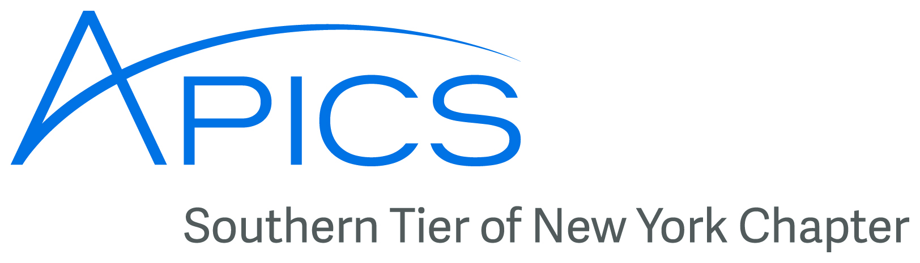
September – October
2016
www.stapics.org
www.facebook.com/stapicsss

News from the APICS International Conference 2016
Washington, DC – The 2016 APICS International Conference was a big event for the Southern Tier chapter as well as the Binghamton University Student chapter. Here are some highlights from the big weekend.

Binghamton University Team in Supply Chain Competition

Last February this student team won the APICS Northeast District supply chain problem solving competition, qualifying for a spot in the international competition. Although they did not make the final stage, they learned a lot and went head to head with student teams from the top universities around the world. Congratulations to our student team!
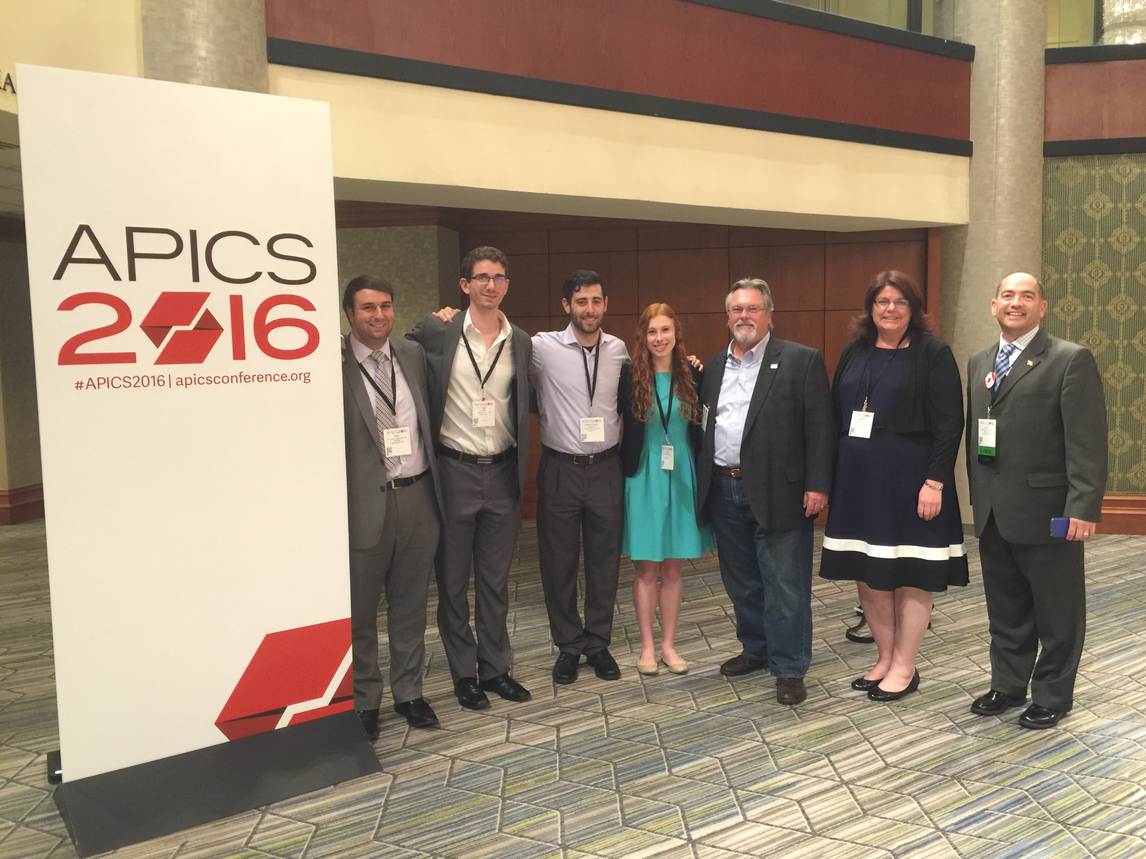
(Left to right: Sam Clarke, Peter Mattar, David Berlin, Kate Butera, coach Don Sheldon, APICS Northeast District Administrators Jennifer Kevlin, Joost Vles.

STAPICS Board Member and BU Professor Don Sheldon Wins Award

Don Sheldon was selected as the recipient of the 2016 APICS Student Mentor Award. The Student Mentor Award recognizes superior leadership and exceptional contributions with an uncommon commitment to the APICS vision and mission.

(Continued below)

Upcoming Events
November B.O.D. Meeting
Wednesday, November 9th at 7PM Location TBD.

Westcode Plant Tour
Wednesday, November 16th at 6PM

Join STAPICS as we tour the Westcode manufacturing plant! The Westcode Group holds a leading position in its chosen markets. It offers its customers bespoke designs of HVAC, door, and Pneumatic and Brake components, manufactured to the highest possible standards. Westcode has sold over $400 million in equipment and is a supplier to ALL the major transit car builders, and many of the transit authorities. From its headquarters in Chadds Ford, Pennsylvania the company has expanded by building new “State of the Art”, air conditioning assembly facilities in Binghamton.

Please RSVP to Steve.Stanchak@Ricoh-USA.com
by November 4th

Location:
Westcode, Inc.
2226 Airport Rd
Binghamton, NY 13905
www.westcodeus.com/index.html

News from the APICS International Conference 2016 (continued)

Don Sheldon was presented the Student Mentor Award during the conference by amdinistrators from the APICS Northeast District Joost Vles and Jennifer Kelvin.
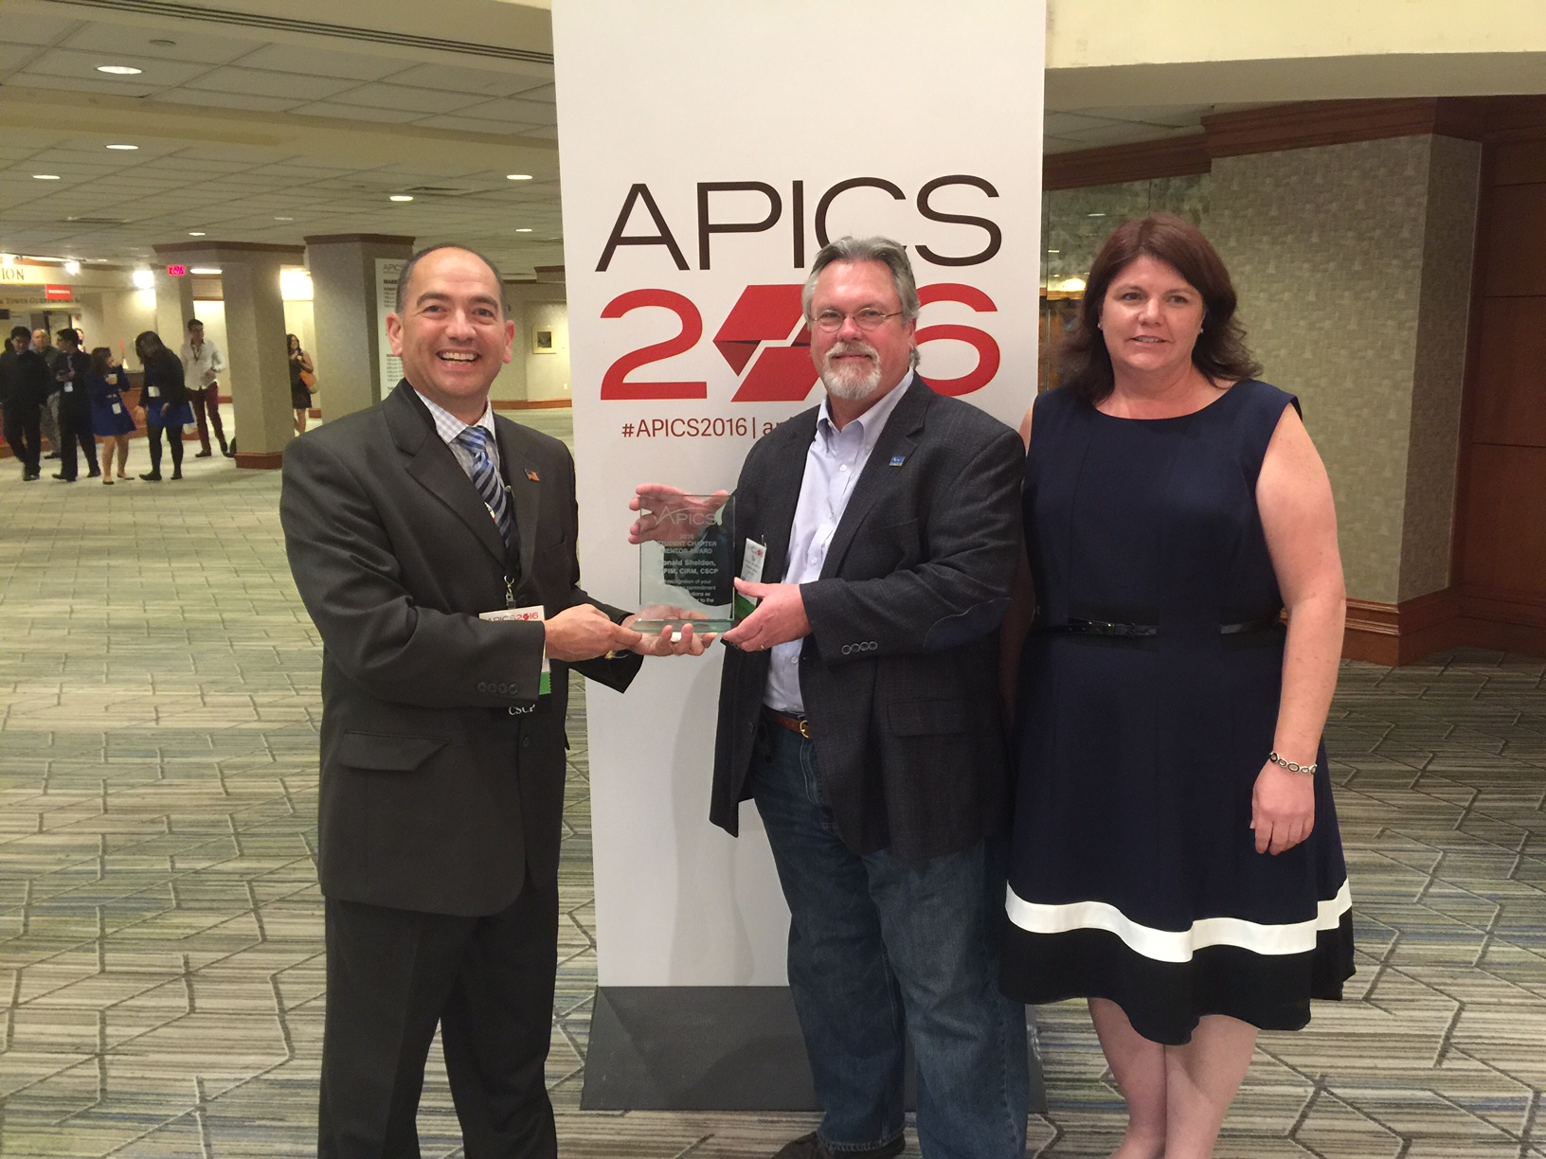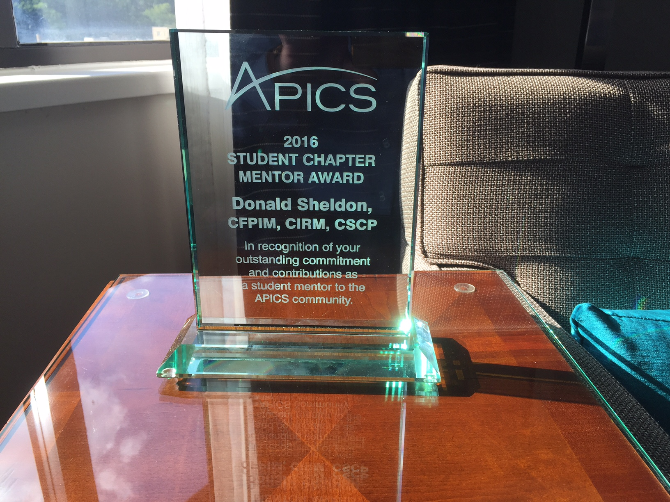
Don Sheldon (center) with APICS Northeast District Administrators Joost Vles (left) and Jennifer Kevlin (right) | The Award.

Binghamton University Management Students Awarded Scholarships

Steven Mandeville and Peter Behan both received scholarships to participate in the APICS SCC 2016 Scholars Education Program at the International Conference. As APICS Supply Chain Council Scholars, they had the opportunity to attend educational sessions and networking events, visit the expo, and volunteer at the conference.

It is extremely rare for multiple students from one university to be awarded this opportunity. Congratulations students!

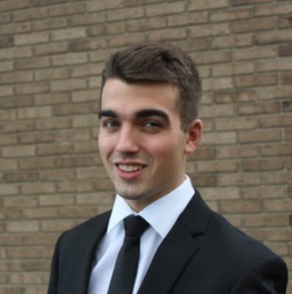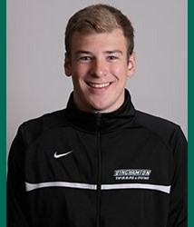
Steven Mandeville Peter Behan

BU Student Chapter Update
Body

Update from Don Sheldon, Director of Education

APICS Courses – We do have a couple APICS CPIM courses being delivered through SUNY Broome for a local company on their campus but no interest has been communicated for a public course. We continue to offer training in whatever APICS subject areas that generate appropriate interest. As always, we need only 4-5 people signed up to run any class. We can run multiple classes at the same time if the 4-5 minimum is met in each one. We also can also offer classes at your company’s facility if there is a need/desire. Just let us know.

Please contact dsheldon@sheldoninc.com if you have training needs you would like to see offered. This includes any of the CPIM courses as well as APICS Lean, APICS Principles, CLTD and/or APICS CSCP.

The CPIM certification has been restructured – You may have noticed in recent APICS corporate communications that the CPIM 5-exam structure will be changing. It is headed toward a 2-exam structure. If you are in the middle of the process you will be able to finish as is, within some, yet to be communicated deadline. The two exams will be the same Basics of Supply Chain Management plus another aggregate exam covering the other 4 modules. The materials and body of knowledge required to successfully pass the exams remains the same. More will be communicated as information is available.
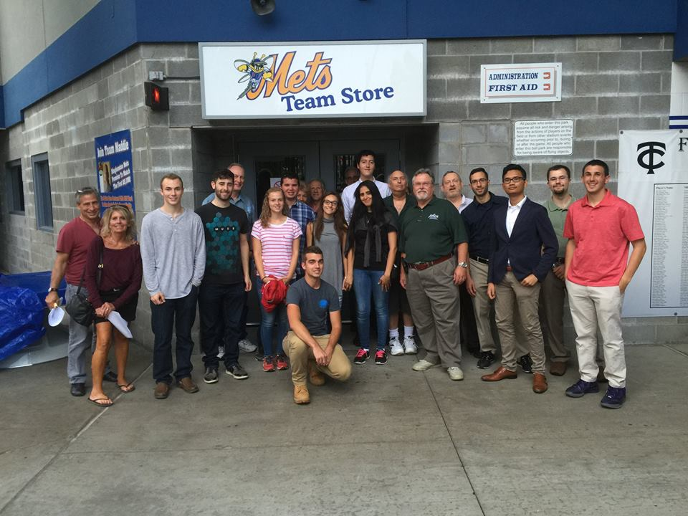
Recent Tour – We had a great turnout for the recent tour of the B Mets operation.
I learned a lot.
Special thanks to all the students and guests that attended!

In Closing – Again, let us know if there are training needs you want to see offered. We are ready and happy to fill the need!

Thank you!
Don Sheldon, Director of Education
Southern Tier Chapter of APICS
dsheldon@sheldoninc.com
Have News or Items of Interest?
To have it included in next month’s newsletter email it to jedestrada.writer@gmail.com by next month’s Board of Directors meeting on November 9th.

Board of Directors 2016

President  Dave Gardner, CPIM  dgardner@emtmetals.com  Executive VP /Director of Finance  Steve Whited  steven.whited@acco.com  Secretary  Debbie Unkel, CPIM  deb.unkel@raymondcorp.com  Director of Programming  Steve Stanchak, CPIM  sstanchak@stny.rr.com  Director of Marketing and Publicity  Open | Director of Membership/Director of Chapter Standards/Director of Online Publication  Lee Schechter , CPIM  lschechter@stny.rr.com  Director of Education/2nd Director of  Student Relations  Don Sheldon, CFPIM CIRM CSCP  dsheldon@sheldoninc.com  Director of Communications  Jed Estrada  jedestrada.writer@gmail.com  Student Chapter Liaison  Samar Al-Hihi  salhihi1@binghamton.edu

Southern Tier APICS
PO Box 1197
Binghamton, NY 13902
www.stapics.com
www.facebook.com/stapics

